11th May 2020

Dear Patient

Information and support for your health and wellbeing
You might be feeling very worried right now due to the coronavirus pandemic (also known as COVID-19) and how it is affecting you, your family and your friends.

- Our Services

- We want you to know that we are still here to look after you and support you as and when you need us

- At the moment we are operating in a different manner. There are less face-to-face appointments and many more telephone and video calls being made.

- Your health

- If you are feeling unwell or are worried about your health – either because of new symptoms or because your usual health problems are getting worse, please contact us.
By telephone:
Please contact us – we are still open for business. Calls may take a little longer to answer on our switchboard but we will endeavour to manage and direct your call to the most appropriate person to help with your medical query / need.

Call us on: 0161 241 8039

By Email:

Please contact us by email- we are still open for business. Email allows you to securely send us requests without waiting on our call lines, which we appreciate can be very busy. We aim to respond to queries within 48 hours, often sooner. Our reception team are constantly reviewing our practice email inbox.

Email us: nmccg.hazeldenemc@nhs.net

By Online Consultation:
Did you know we can offer you an online consultation?. Simply go to our website and click on this link shown.
https://hazeldenemanchester.nhs.uk/

Online Consult allows you can submit questions or concerns about your health condition to us online. We aim to respond the same working day to your query and give you feedback about your query and can even book you a telephone, video or face to face consultation if we feel you need a follow up assessment.

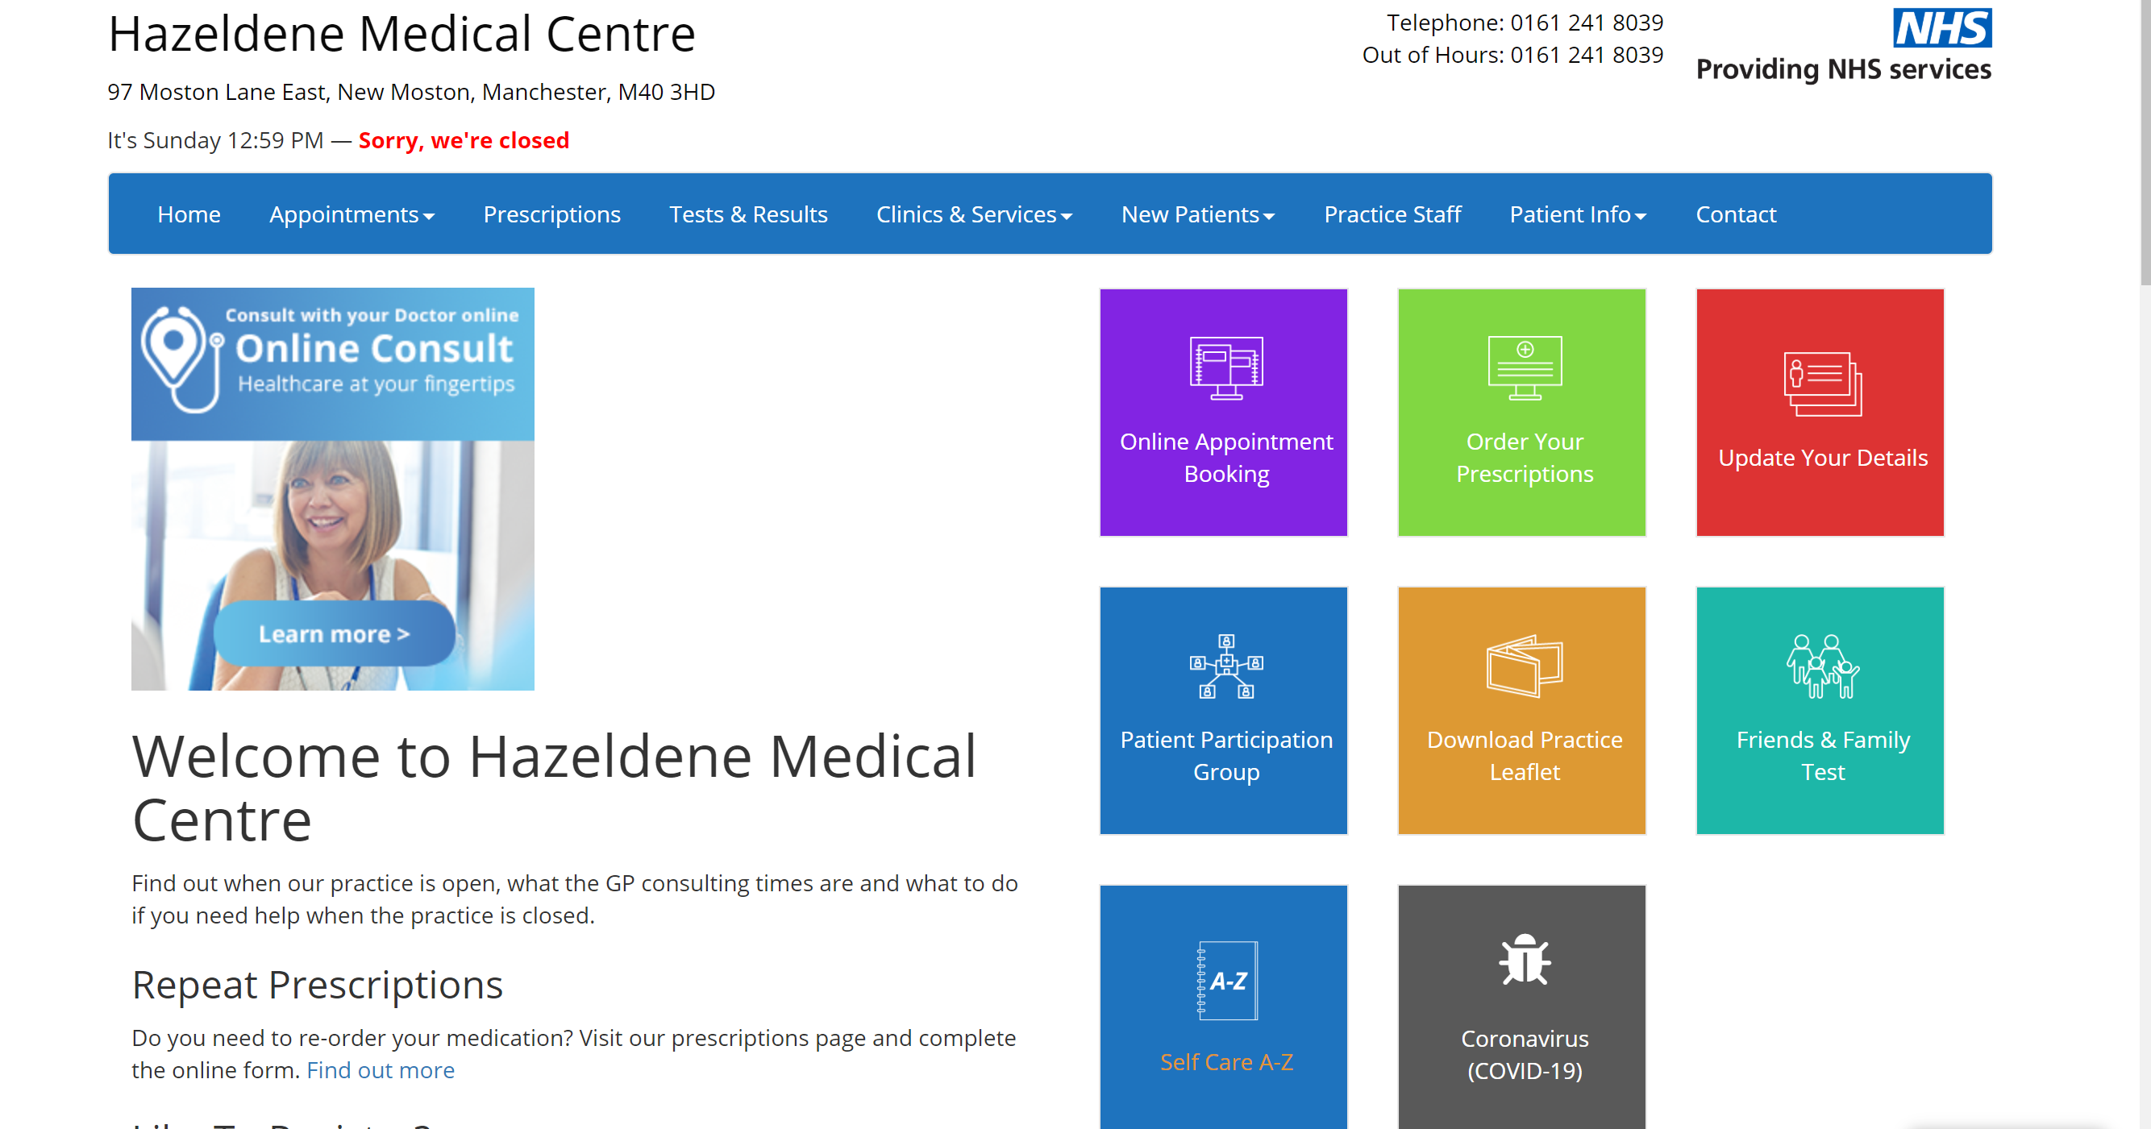

- You can also contact NHS 111, day and night (24 hours a day, 7 days a week) by calling 111 or by going online to 111.nhs.uk
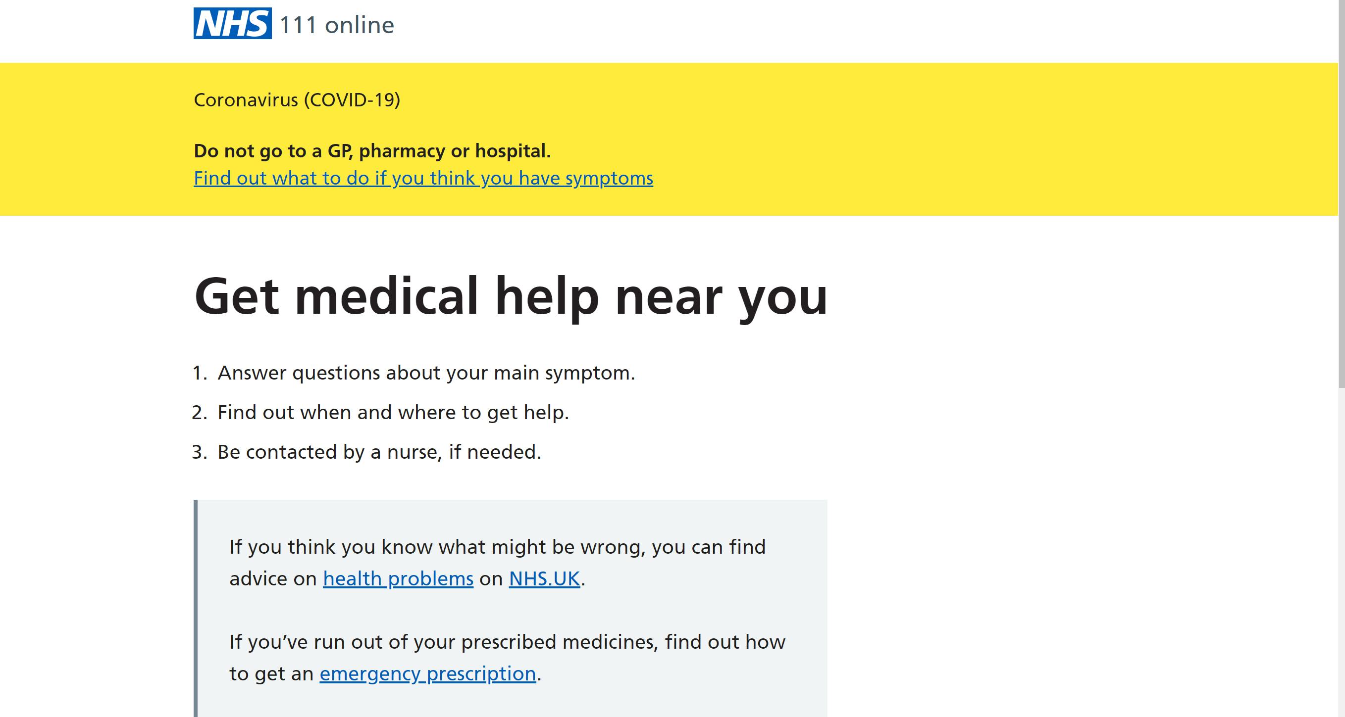

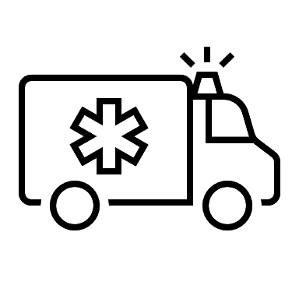

- Call 999 if you have:
  - Signs of a heart attack - pain like a very tight band, heavy weight or squeezing in the centre of your chest
  - Signs of a stroke - face drooping on one side, can’t hold both arms up, difficulty speaking
  - Severe difficulty breathing - gasping, not being able to get words out, choking or lips turning blue
  - Heavy bleeding - that won’t stop
  - Severe injuries - or deep cuts after a serious accident
  - Seizure (fit) - someone is shaking or jerking because of a fit, or is unconscious (can’t be woken up)
  - Sudden, rapid swelling - of the eyes, lips, mouth, throat or tongue
2. Supplies of food and medication
- If you are unable to leave the house to get supplies of food and medication, ask a trusted family member, friend or neighbour if they can help you with this. If there is no-one you can ask, please contact:

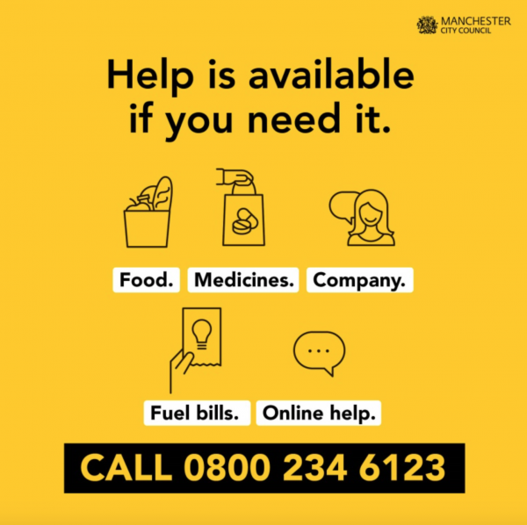
- Please do not go without food or your medication at this time – there is help available.

- Do not give your bank details or hand over money to people you do not know or do not trust.

3. You have the right to feel safe in your home
- If anyone is making you feel unsafe or frightened, for example, by threatening you in your home or by stealing money from you, please tell someone such as
  - The Police
  - Your local council
  - Any professional involved with supporting you such as a social worker, support worker or your GP

4. Trusted sites to get up to date information on COVID-19
At the moment, there is a lot of coverage from all media and although it is important to stay informed, consider taking a break if you feel things are getting on top of you. Sometimes feeling stressed or anxious can be related to seeing lots of media coverage and new stories about the impact of COVID-19, it is OK and normal to feel this way.

Only take advice from trusted government and health service websites. These have all the latest facts and figures to give consistent advice on how to prevent spreading, catching it and what to do if you think you have the Coronavirus.

NHS (nhs.uk) website COVID-19 advice
- https://www.nhs.uk/conditions/coronavirus-covid-19/

Government (gov.uk) websiteCOVID-19 advice
- https://www.gov.uk/government/publications/coronavirus-outbreak-faqs-what-you-can-and-cant-do/coronavirus-outbreak-faqs-what-you-can-and-cant-do

Age UK Information Guide on COVID-19
- https://www.ageuk.org.uk/globalassets/age-uk/documents/information-guides/ageukig59_coronavirus_inf.pdf

5: Help your emotional and physical well-being
Having to be in ‘lockdown’, socially isolate and distance yourself from your friends and family members may make you feel stressed and anxious. It is not surprising that each day can feel totally different to the next and this is unsettling. It is very normal to feel worried and unsure about things.
We want you to look after yourself during these difficult times.
The following resources can help with your emotional and physical well-being.

Websites offering emotional well-being and support

Domestic Abuse Aware Practice
The staff in your GP practice are trained to ask about domestic abuse and specialist workers are available to support you. Your practice is an ‘IRIS’ practice. You can talk to doctors, nurses and other staff working here if you are being hurt or controlled by your current or ex-partner, are afraid of someone at home or a member of your family.
The IRIS service is for all GP patients and staff, both women and men, aged 16 or over, whatever age, gender, sexuality, ethnicity or background. IRIS’s oldest patient so far is 87.
Social isolation can increase stress at home, impacting on you and your family’s well-being. Your GP practice is here to help you.
Please contact your GP or practice nurse for help and advice. They will refer you to the IRIS worker, the ‘IRIS Advocate Educator’.

IRIS Office: 0161 820 8416 9am - 4.30pm.
Manchester Women’s Aid 0161 660 7999
For advice on how to cover your tracks on-line go to: https://www.womensaid.org.uk/cover-your-tracks-online/
In an emergency call the Police on 999.
National DA Helpline
This is a 24 hour National domestic abuse helpline.
Telephone: 0800 2000 247
Website: www.nationaldahelpline.org.uk

Silent Solutions Police
In an emergency call 999 for the Police. If you cannot safely speak to the operator to ask for the Police, stay on the line and the call will be forwarded to an operating system. Press 55 to be transferred to the local police force as an emergency.
Silent Call Police: dial 999, wait, then press 55.
Bright Sky
Bright Sky is a free to download mobile app providing support and information to anyone who may be in an abusive relationship, or those concerned about someone they know. Available in four languages: English, Urdu, Punjabi and Polish.
Website: www.hestia.org/brightsky
Other Contacts you may find of help:
Greater Manchester Domestic Abuse Helpline – 0161 636 7525
Manchester Women’s Aid – 0161 660 7999
LGBT Domestic Violence Helpline – 0300 999 5428
Saheli Asian Women’s Project – 0161 945 4187
Community Helpline Language Service (Urdu and Punjabi) :
0161 636 7525

Websites offering mental health support

MIND (Mental Health Support with specific advice on ‘Coronavirus and your wellbeing’
- https://www.mind.org.uk

Samaritans (Resources and help for all ages)
- https://www.samaritans.org/
- Call 116 123

Websites offering advice on keeping fit, physical well-being
Free 30 day Yoga course
- https://www.youtube.com/watch?v=--jhKVdZOJM

Herts sports partnership (workout from home)
- https://sportinherts.org.uk/workoutfromhome/

SuperBetter (Builds personal resilience and boosts physical and emotional wellbeing)
- https://apps.apple.com/gb/app/smiling-mind/id560442518

The Football Association (Staying fit at home)
- http://www.thefa.com/get-involved/footballs-staying-home

21 best home exercises for men (workout from home)
- https://www.menshealth.com/uk/building-muscle/a754099/the-15-best-beginners-exercises-to-do-at-home/

Please keep safe and healthy
Best wishes,
Hazeldene Medical Centre

Acknowledgements for collating & editing:
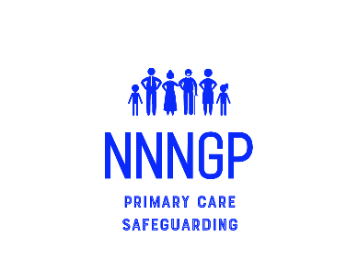
Ms Megan Burack, Medical student at Queens Medical Centre,
University of Nottingham and NHS Volunteer

In collaboration and with thanks to the Executive members of:
the Primary Care Safeguarding Forum (PCSF), National Named Network of GPs (NNNGP)
and the Royal College of General Practitioners Adolescent Working Group (RCGP AWD)

